Hardware
Parts List:
- 1 MAX31856 Thermocouple Board
- 1 Arduino Nano
- 1 Pack of breadboard/jumper wires (female to female)
- 1 USB-A to USB-B cable
- 3d printed case
- Thermocouples
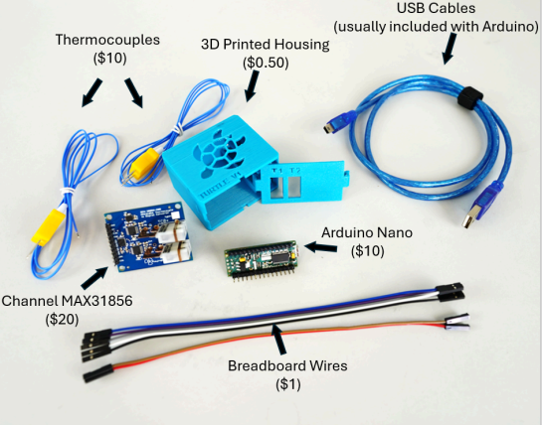

Step 1: Attach the wires between the two boards
Thermocouple Board |  | Arduino Nano
GND |  | GND
V+ |  | VIN
CSO |  | Pin 10
SCK |  | Pin 13
SDO |  | Pin 12
SDI |  | Pin 11
CS1 |  | Pin 9

Step 2: Orientate the device inside the case
Slide the Arduino Nano into the right side of the case. The USB port of the of the Arduino Nano should face the back of the case so that the port slides into the small hole in the back of the case.
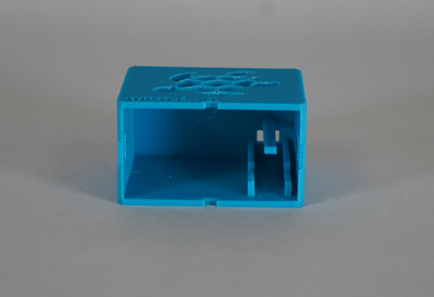

Next orientate the wires into the open area of the thermocouple board.
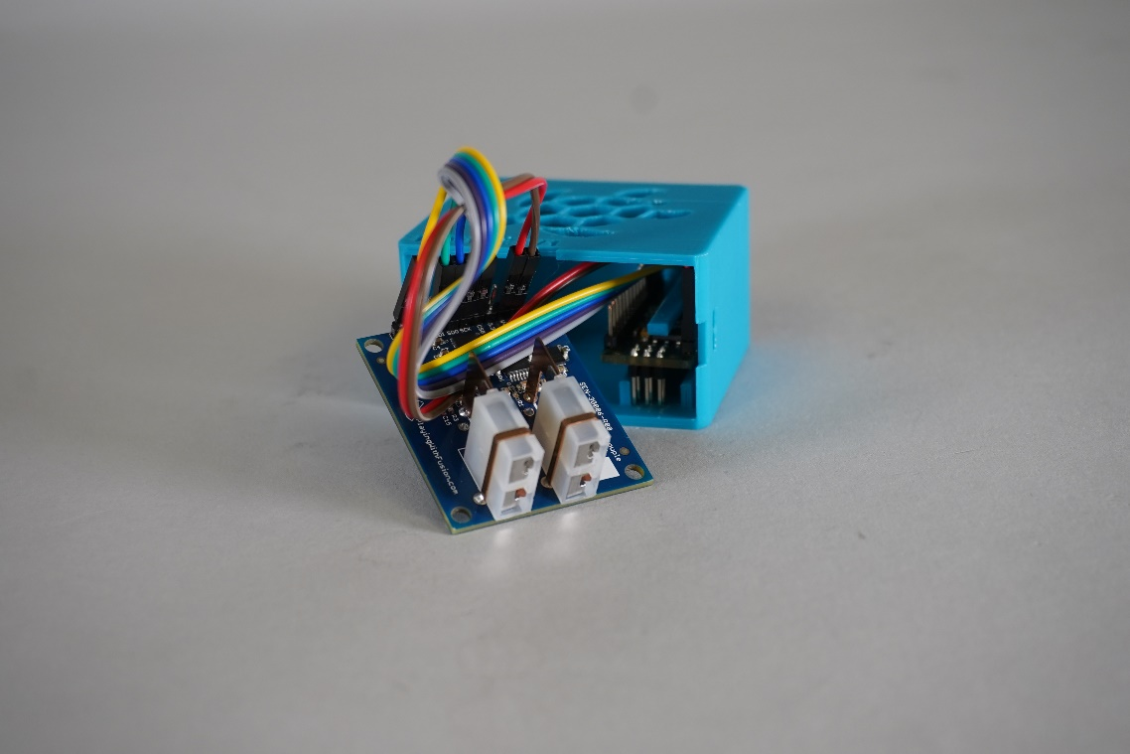
With the wires tucked away, slide the thermocouple board into the case with the connectors facing out.
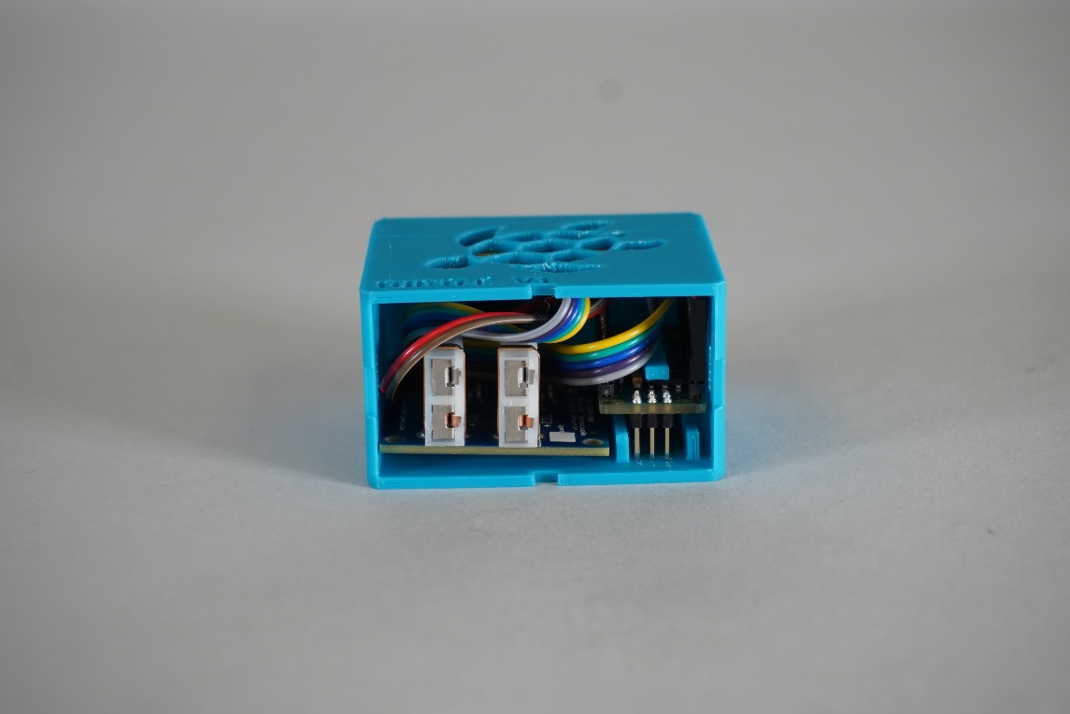
Step 3: Snap on the cover
Snap the cover onto the case with the symbols “T1” and “T2” facing up
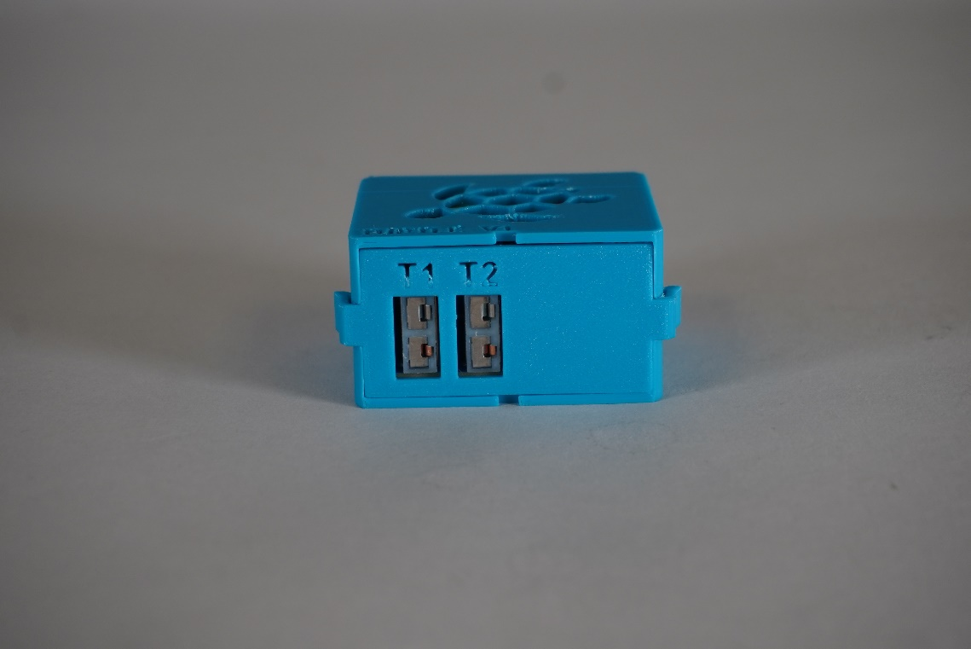

Software
Step 1: Download Arduino IDE
The Arduino IDE can be downloaded here https://www.arduino.cc/en/software
Step 2: Install Thermocouple Library
Go to the file labeled Temp_LoggerV3.cpp and open it using the Arduino IDE. From there click on the icon that looks like books and type in the search bar “MAX31856”. Click install under the version by Adafruit. Keep the Arduino IDE open for the next step.
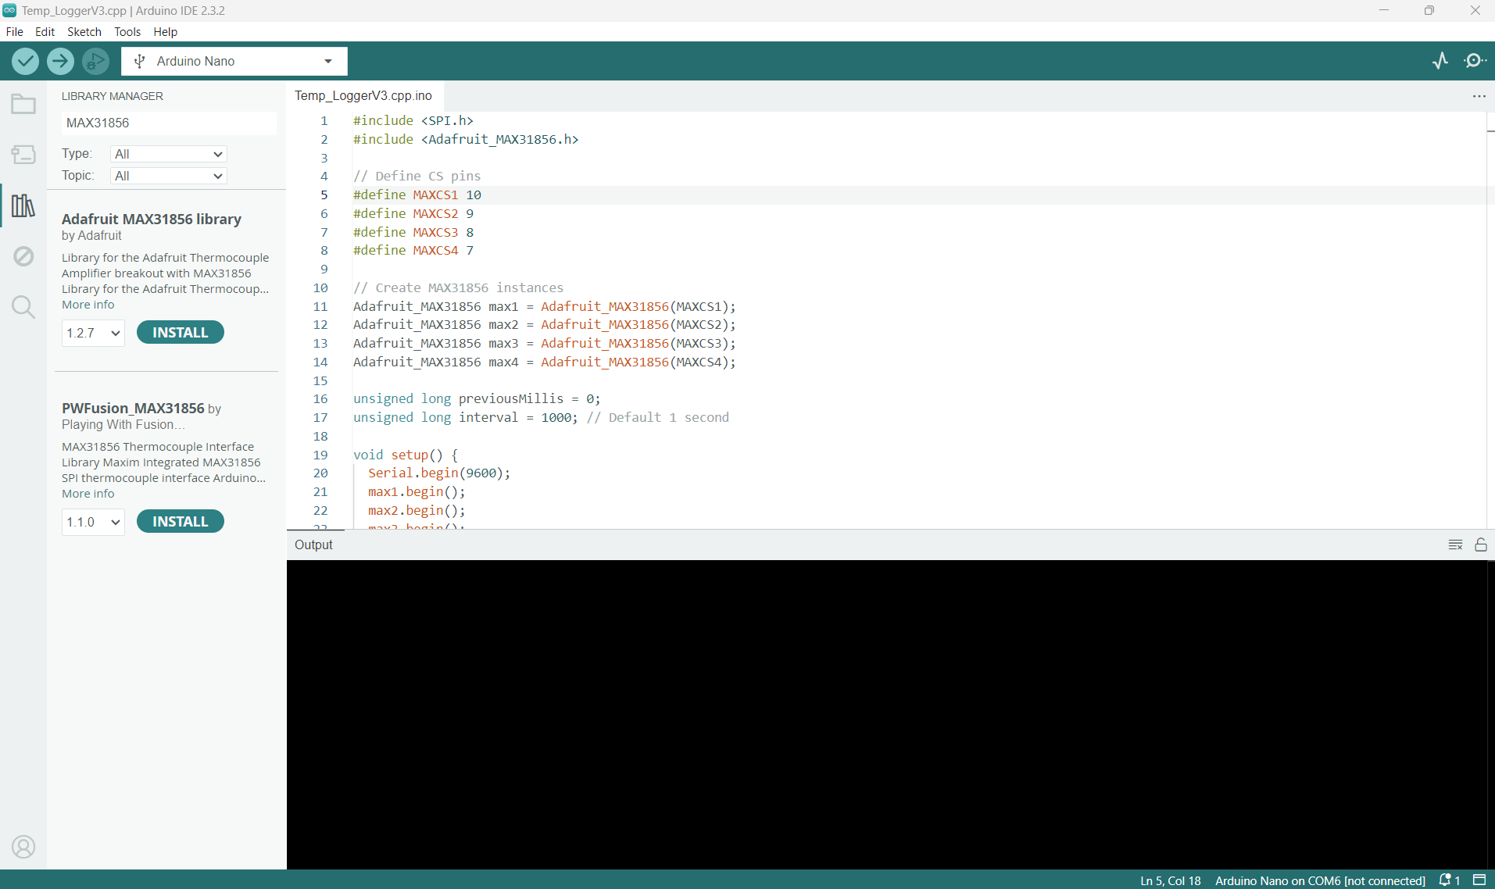

Step 3: Flashing code onto the Arduino Nano
Attach the USB cable to the back of the TURTLE and the other end to your computer. In the Arduino IDE push the “Tools” drop down. From the tools drop down navigate to “Board:” and then “Arduino AVR Boards” and select “Arduino Nano”
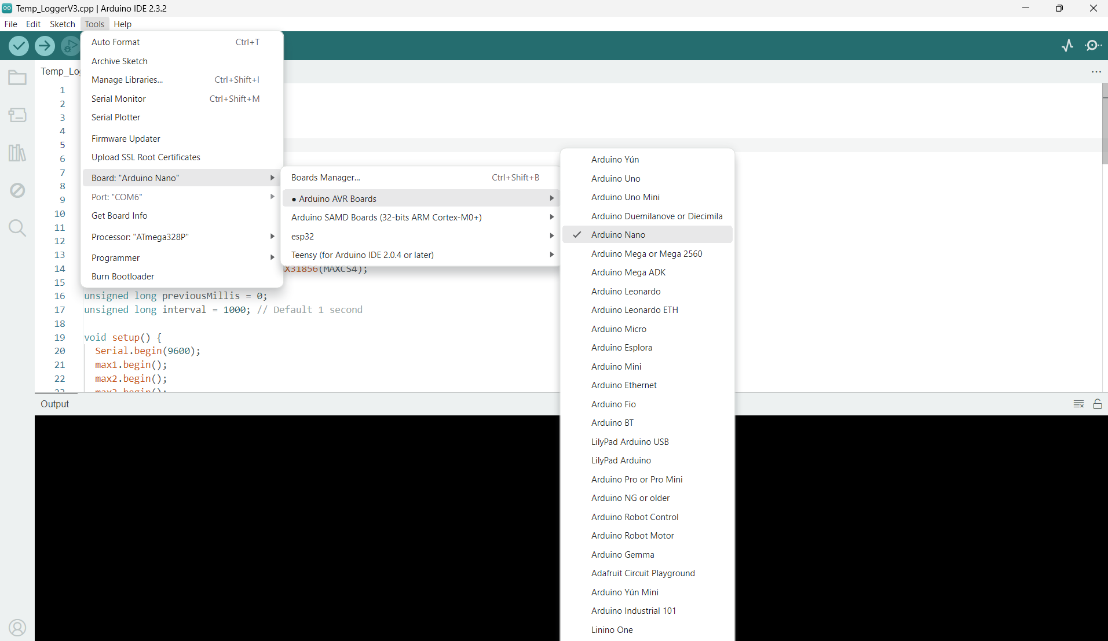

Next push the “Tools” drop down menu again but instead select “Port:”. From there select the port assigned to your Arduino.
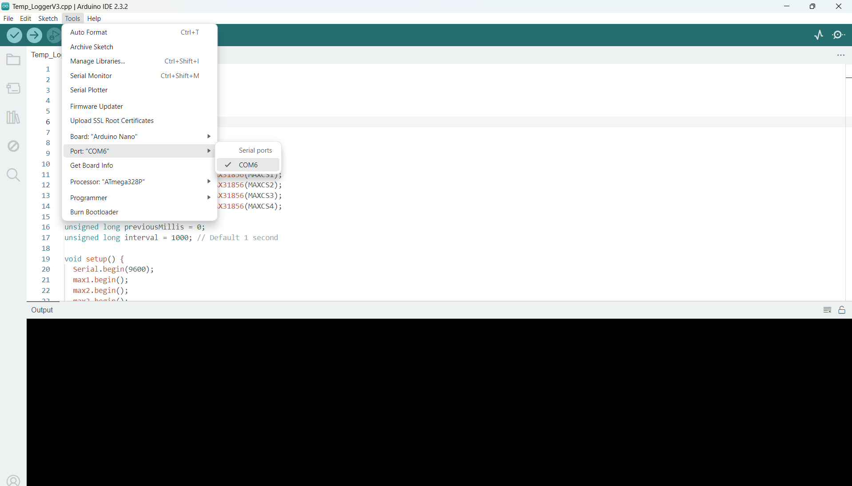

Finally push the arrow button at the top left of the screen which will flash the code onto the Arduino.
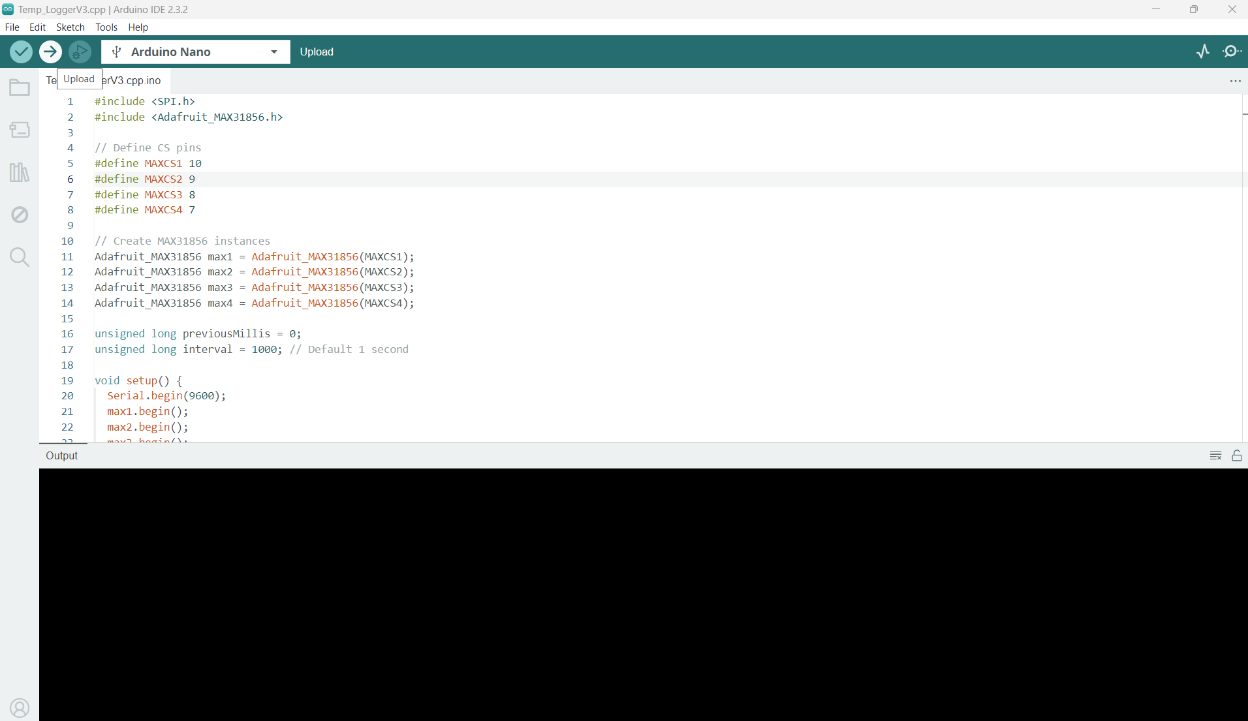

Step 4: Download python onto your computer
You can do this here https://www.python.org/downloads/ Once you have downloaded the installer double click it and it will run you through a short setup wizard. Once the setup wizard is open make sure the check box labeled “Add python.exe to PATH” is checked and then push Install Now shown below.

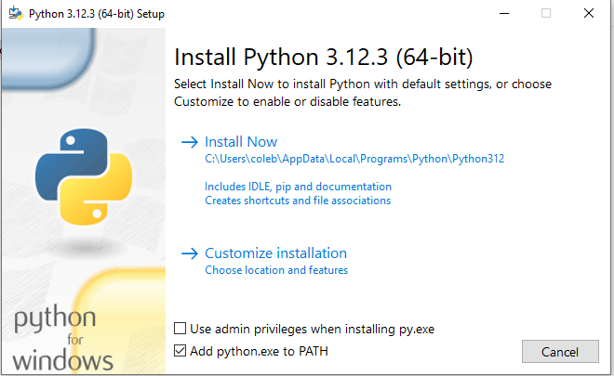

Step 5: Download necessary python libraries
To do this search for “Command Prompt” in the search bar next to the windows logo.
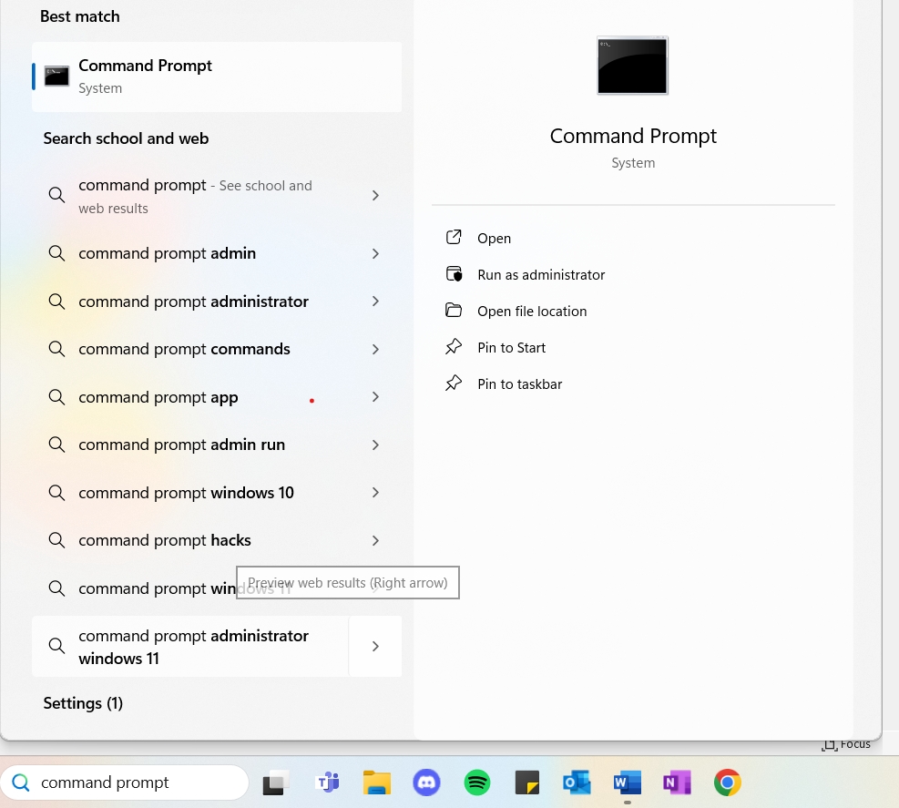
Open the Command Prompt and copy and paste the following:
pip install pyserial
pip install pandas
pip install matplotlib
pip install customtkinter
pip install numpy
pip install os
pip install xlsxwriter

Step 6: Run the program!!!
Now you should be able to simply double click the file named Temp_LoggerV3 every time you want to run the application.

